A
Project Report
on
AI Smart Campus Management System
Submitted in Partial Fulfilment of the requirements for the award of the degree of
Bachelor of Computer Application
In
Session 2025-26 program under the

Maharishi University of Information Technology, Noida
Submitted By:

Deepanshu Kumar - 2302031601034(A)
Mayank Jain - 2302031601051(A)
Chetan Sharma - 2302031601030(A)
Prachi - 2302031601130(A)

UNDER THE GUIDANCE OF
MS Keerti Thakur

Assistant Professor , MSOET, Noida


Maharishi School of Engineering & Technology
Maharishi University of Information Technology
Noida-201304
www.muitnoida.edu.in
DECLARATION
We, hereby declare the work, which is being presented in the project, entitled "AI Smart Campus Management System" in partial fulfillment of the requirements for the award of the degree of Bachelor of Computer Application, is an authentic record of our own work carried out under the supervision of Mr. Amiya Dhar Dwivedi.
The matter embodied in this project has not been submitted by us or anybody else for the award of any other degree in any other University/Institution.
Deepanshu Kumar 2302031601034 (A)
Mayank Jain 2302031601051 (A)
Chetan Sharma 2302031601030 (A)
Prachi 2302031601130 (A)
This is to certify that the above statement submitted by the candidate is correct to the best of our knowledge and belief. However, responsibility for any plagiarism related issue stands solely with the students.

Name of Supervisor : Ms. Keerti Thakur | Signature

Date: _______________

ACKNOWLEDGEMENT

We are grateful to many people who have helped me throughout my bachelor of Computer Application. First, we would like to thank Prof. (Dr.) Awakash Mishra Dean MSoET, Dr. Savita (HoD-BCA), Mr. Amiya Dhar Dwivedi (Project Coordinator) and my supervisor, (MS. Keerti Thakur) for their intimacy and for their great support during all the steps of this report. we would also like to thank my faculty members and my colleagues for their valuable suggestions. Besides our colleagues, we appreciate the care and support of our good friends, who always encouraged us towards this research work.
Last but not the least, if we had the chance to append an acknowledgement for our life, it would give us immense pleasure to express our deep gratitude towards our family members for their existence and being the reason for our thereupon.

Deepanshu Kumar
Univ. Roll No.- 2302031601034
Mayank Jain
Univ. Roll No.- 2302031601051
Chetan Sharma
Univ. Roll No.- 2302031601030
Prachi
Univ. Roll No.- 2302031601130

S No. | Contents | Page No.

TABLE OF CONTENTS
1 Chapter-1 1-8
1.0 | Introduction | 1
1.1 | Objective & Scope of the Project | 2
1.2 | Definition of Problem | 3
1.3 | System Analysis & Design via User Requirements | 4
1.4 | Methodology and System Planning | 5
1.5 | Proposed System | 6
1.6 | Feasibility Study | 7
1.7 | Hardware & Software Requirements | 8
2. | Chapter-2 | 9-17
2.0 | What is DFD & How to Prepare a DFD? | 9
2.1 | DFD (At least up to Level 2) | 10-11
2.2 | Database Design | 12
2.3 | ER Diagram | 13-14
2.4 | Flow Chart | 15-16
2.5 | Meta Data | 17
3. Chapter-3 18-20
3.0 | Cost and Benefit Analysis | 18
3.1 | Challenges | 19-20
4. | Chapter-4 | 21-31
4.0 | Snapshots | 21-29
4.1 | Future Scope | 30-31
5. | Chapter-5 | 32-35
5.0 | Conclusion | 32
5.1 | Advantages | 33
5.2 | Limitations | 34
5.3 | Enhancements | 35
6 | Bibliography | 36

LIST OF TABLES
S. No | Tables | Page No.
Table 2.2.1 | User Table | 11
Table 2.2.2 | Complaint Table | 11
Table 2.2.3 | Notice Table | 12
Table 2.4.1 | Symbol Flow Chart | 16
Table 2.5.1 | Meta Data  Table 3.1 Benefit Analysis 18 | 17
Name of Table : List of Tables

LIST OF FIGURES
S. No. | Figures | Page No.
Figure 2.1.1 | Context Level DFD (Level 0) | 10
Figure 2.1.2 | Level 1 DFD Diagram | 11
Figure 2.3.1 | ER Diagram | 14
Figure 2.4.1 | Flow Chart  Figure 4.1.1 Login Page 21  Figure 4.2.1 Student Dashboard 22  Figure 4.3.1 Form Generator 23  Figure 4.4.1 Submission Form 24  Figure 4.5.1 Status Tracker 25  Figure 4.6.1 Student View 26  Figure 4.7.1 Admin Dashboard 27  Figure 4.8.1 Admin-Manage Complaints 28  Figure 4.9.1 Admin-Post New Notice 29 | 15

Name of Table : List of Figures

CHAPTER-1

1.0 Introduction
In today's technology-driven academic environment, managing a campus efficiently requires a unified digital platform that can handle diverse administrative tasks seamlessly. Traditional campus management systems often rely on paper-based complaint submissions, physical notice boards, and manual administrative workflows, which are slow, error-prone, and difficult to track. The AI Smart Campus Management System is designed to address these limitations by integrating Artificial Intelligence with modern web technologies to automate and streamline campus operations.
This project focuses on two core modules: a Complaint Management System and a Digital Notice Board. The Complaint Management System allows students and staff to submit complaints digitally. A key innovation of this module is the AI-powered complaint form generator, which automatically fills in relevant complaint details based on a set of instructions provided by the user, reducing the effort required to write detailed complaint descriptions. The Digital Notice Board module enables administrators to publish, schedule, and display announcements to the campus community in real time, replacing outdated physical boards.
By combining AI automation with intuitive design, the AI Smart Campus Management System empowers both students and administrators to communicate and resolve issues faster, ensures transparency in complaint resolution, and provides a centralized platform for campus-wide information dissemination. This system represents a step toward creating a smarter, more connected, and more efficient academic ecosystem.

1

1.1 Objectives
In traditional campus environments, complaints are submitted manually, notices are posted on physical boards, and administrative processes are slow and difficult to monitor. The AI Smart Campus Management System is built to resolve these inefficiencies.
The main objectives of the project are:
- To provide an AI-powered complaint form that automatically generates complaintcontent based on user-provided keywords or short instructions.
- To allow students and staff to submit, track, and view the status of their complaintsthrough a user-friendly interface.
- To enable campus administrators to post, edit, and manage digital notices visible to allusers across the campus.
- To implement a role-based access control system distinguishing between Students,Staff, and Administrators.
- To display real-time digital notices on a dedicated notice board page, replacing theneed for physical boards.
- To maintain a complaint resolution workflow where administrators can update thestatus (Pending, In Progress, Resolved) of submitted complaints.
- To provide a search and filter functionality for both complaints and notices.
- To make the system accessible and responsive across devices including desktops,tablets, and mobile phones.

2

1.2 Definition of Problem
Most educational institutions today still rely on outdated methods for managing student complaints and campus-wide communications. This creates significant operational challenges:
- Students must physically visit offices to submit complaints, causing delays and lack oftraceability.
- There is no automated mechanism to draft complaint descriptions, making the processtedious for users.
- Physical notice boards are often outdated, damaged, or inaccessible to students inremote or large campuses.
- Administrators have no centralized dashboard to track, manage, and resolve complaintsefficiently.
- There is no notification system to alert users when their complaint status changes.
- Important announcements may reach students late or not at all due to the absence of adigital broadcasting channel.
These problems reduce institutional efficiency, lower student satisfaction, and create gaps in administrative accountability. Our project aims to identify these gaps and build a platform that automates complaint handling and digitizes campus communication using Artificial Intelligence.

3

1.3 System Analysis & Design via User Requirements
System Analysis involves understanding what students, staff, and administrators need to interact with the campus management platform efficiently.
User Requirements include:
- Students need a simple form to submit complaints with an AI-assist button thatauto-fills the complaint description.
- Students need to track the status of their submitted complaints in real time.
- Staff need to view complaints assigned to their department and update resolutionstatus.
- Administrators need a dashboard to manage all complaints, notices, and user roles.
- Administrators need the ability to create, edit, schedule, and delete digital notices.
- All users need a responsive interface accessible on desktops and mobile devices.
System Design ensures the platform is intuitive, role-aware, and follows modular design principles. Using user-centered design methods, the system will meet the needs of all campus stakeholders through clear workflows and AI-assisted input capabilities.

4

1.4 Methodology and System Planning
The project will use a step-by-step approach:
- Requirement Gathering: Understanding campus management challenges through research, discussions with students and staff, and analysis of existing systems.
- Design: Creating system diagrams including context DFD, Level-1 DFD, ER diagrams, and flowcharts to model the system architecture.
- Development: Using HTML, CSS, JavaScript for the frontend, Python (Flask) for the backend, and MySQL as the database. AI complaint generation uses a predefined NLP-based instruction parser.
- Testing: Performing functional testing for complaint submission, notice posting, AI form generation, and role-based access control using manual and browser-based test cases.
- Deployment: Hosting the application on a local server initially, then deploying to a cloud platform for real-world usage.
This methodology ensures all system modules are built iteratively with clear milestones, and that both technical accuracy and user experience are prioritized throughout the project lifecycle.

5

1.5 Proposed System
The proposed system provides an integrated AI-powered campus management platform with two primary modules: Complaint Management and Digital Notice Board. The system is accessible through a web browser and supports three user roles: Student, Staff, and Admin.
Main Features of the Proposed System:
- AI-Powered Complaint Form: Users provide a short description or keyword set, and the AI engine automatically generates a complete, well-structured complaint form with subject, category, and detailed body text.
- Complaint Submission & Tracking: Students can submit complaints and view a status dashboard showing Pending, In Progress, or Resolved statuses.
- Admin Complaint Dashboard: Administrators can view all complaints, filter by department or priority, assign complaints to staff, and update resolution status.
- Digital Notice Board: Administrators can create digital notices with title, content, category, and expiry date. Notices appear on the campus-wide notice board in real time.
- Role-Based Access Control: Each user type (Student, Staff, Admin) sees only the features and data relevant to their role.
- Responsive Design: The interface adapts to all screen sizes including mobile, tablet, and desktop.
- Search & Filter: Users can search and filter complaints and notices by date, category, or status.
This system removes dependency on manual processes and makes campus administration self-supportive, transparent, and AI-assisted.

6

1.6 Feasibility Study

1. Technical Feasibility
- All features (AI form generation, complaint tracking, notice board) are supported byweb technologies such as HTML, CSS, JavaScript, Flask (Python), and MySQL.
- AI-powered form generation can be implemented using pre-trained language models orrule-based instruction-to-text engines available as open-source libraries.
- No specialized hardware is required; the system runs on standard web servers.
- Therefore, the project is technically feasible.

2. Operational Feasibility
- The system is intuitive and can be used by students, staff, and administrators withminimal training.
- The AI-assisted complaint form reduces the effort required from users to write detailedcomplaints.
- Digital notices eliminate the need for physical board maintenance. Users can access thesystem from any device with internet access.

3. Economic Feasibility
- The entire system uses freely available and open-source technologies, keepingdevelopment costs minimal.
- Cloud hosting options are available at low cost for deployment.
- The long-term operational savings from reduced manual effort in complaint handlingand notice distribution justify the development investment.
- Thus, the project is economically feasible.

7

1.7 Hardware & Software Requirements
Hardware Requirements:
- Laptop or PC with at least 4GB RAM (8GB recommended for AI model inference)
- Internet connection for accessing the web application and testing AI features
- Monitor with good resolution for UI design and testing
- Server machine or cloud instance for deployment (minimum 2-core CPU, 4GB RAM)
Software Requirements:
- Front-end: HTML5, CSS3, JavaScript, Bootstrap/Tailwind CSS
- Back-end: Python (Flask Framework)
- Database: MySQL
- AI Module: OpenAI API / Hugging Face Transformers (for complaint formgeneration)
- Tools: VS Code (IDE), Postman (API testing), XAMPP/WAMP (local server)
- Browser: Chrome, Firefox, Edge for cross-browser testing

8

CHAPTER-2

2.0 What is DFD & How to Prepare a DFD?
A Data Flow Diagram (DFD) is a graphical tool used to represent how data moves inside a system. It focuses on data flow, not program logic or design structure. It shows:
  - Where data originates from
  - How the system processes it
  - What modules interact with it
  - How output is generated
DFDs are widely used in system analysis because they are easy to understand even for non-technical users.
How to Prepare a DFD?
To prepare a DFD, follow these steps:
  - Identify external entities — such as the Student, Staff, and Administrator.
  - Identify main processes — such as Submit Complaint, Generate AI Form, PostNotice, Manage Users.
  - Identify data flows — complaint data, notice data, user credentials, AI instructions,status updates.
  - Identify data stores — Complaint Database, Notice Database, User Database.
  - Draw the Level 0 (Context) diagram first, then expand to Level 1 and Level 2 diagrams.

9
2.1 DFD (At least up to Level 2) Level 0 – Context Level DFD:

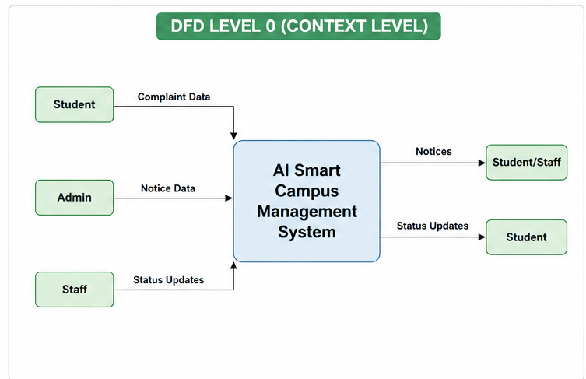Figure 2.1.1: Context Level DFD (Level 0)
Level 1 – DFD (Expanded Processes):
At Level 1, the main system is broken into the following processes:
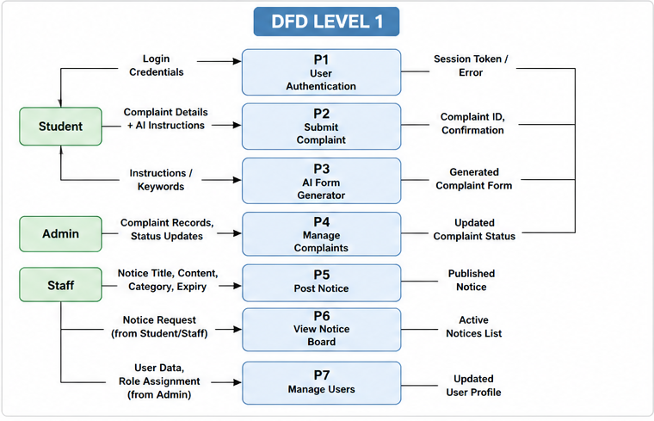
Figure 2.1.2: Level 1 DFD Diagram

10
2.2 Database Design
The database is designed using MySQL with the following primary tables:

Field Name | Data Type |  | Constraints |  | Description
user_id | INT |  | PRIMARYKEY,  AUTO_INCREMENT |  | Unique user identifier
username | VARCHAR(50) |  | NOT NULL, UNIQUE |  | User login name
email | VARCHAR(100) |  | NOT NULL, UNIQUE |  | User email address
password_hash | VARCHAR(255) |  | NOT NULL |  | Encrypted password
Role | ENUM('Student','Staff','Admin”) |  | NOT NULL |  | User role in system
created_at | DATETIME |  | DEFAULT NOW() |  | Account creation time

Table 2.2.1: User Table

11
Field Name | Data Type | Constraints |  | Description
complaint_id | INT | PRIMARY KEY, AUTO_INCREMENT |  | Unique complaint ID
user_id | INT | FOREIGN KEY (users) |  | Complaint submitter
subject | VARCHAR(200) | NOT NULL |  | Complaint subject
category | VARCHAR(100) | NOT NULL |  | Category of complaint
description | TEXT | NOT NULL |  | Full complaint body
status ENUM | ('Pending','In Progress’, ‘Resolved’) | DEFAULT 'Pending' |  | Current complaint status
submitted_at | DATETIME | DEFAULT NOW() |  | Submission timestamp
resolved_at | DATETIME | NULLABLE |  | Resolution timestamp

Table 2.2.2: Complaint Table

Field Name | Data Type |  | Constraints |  | Description
notice_id | INT |  | PRIMARY KEY, AUTO_INCREMENT |  | Unique notice ID
admin_id | INT |  | FOREIGN KEY (users) |  | Notice publisher
title | VARCHAR(255) |  | NOT NULL |  | Notice heading
content | TEXT |  | NOT NULL |  | Full notice content
category | VARCHAR(100) |  | NOT NULL |  | Notice category
expiry_date | DATE |  | NULLABLE |  | Notice expiry date
created_at | DATETIME |  | DEFAULT NOW() |  | Publication time
Table 2.2.3: Notice Table

12

2.3 ER Diagram
The Entity-Relationship (ER) Diagram models the data entities and their relationships in the AI Smart Campus Management System.
Entities and Attributes:

Entity | Attributes
USER | user_id (PK), username, email, password_hash, role, created_at
COMPLAINT | complaint_id (PK), user_id (FK), subject, category, description, status, submitted_at, resolved_at
NOTICE | notice_id (PK), admin_id (FK), title, content, category, expiry_date, created_at
AI_LOG | log_id (PK), user_id (FK), instructions_provided, generated_form, generated_at

Relationships:
- USER submits COMPLAINT (One-to-Many: One user can submit many complaints)
- USER (Admin) posts NOTICE (One-to-Many: One admin can post many notices)
- USER generates AI_LOG (One-to-Many: One user can generate many AI-assistedforms)
- COMPLAINT is managed by USER (Admin/Staff) — Many-to-One

13

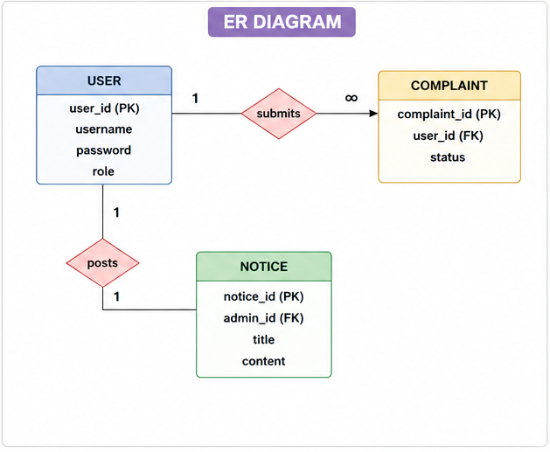Figure 2.3.1: ER Diagram

14

2.4 Flow Chart
The following flowchart describes the complete process flow for the AI-powered complaint submission:

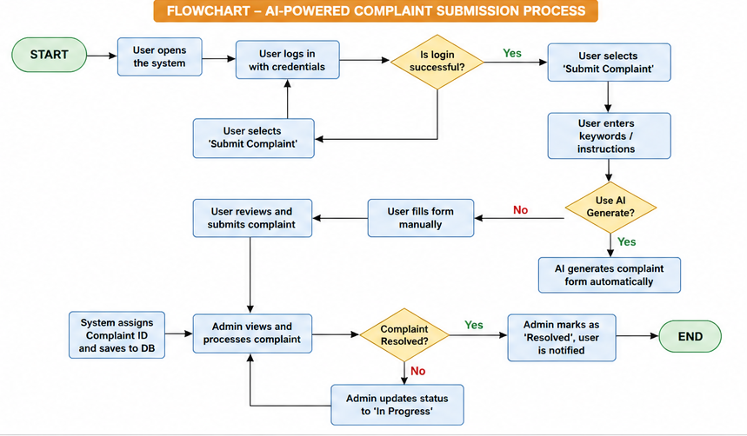
Figure 2.4.1 : Flow Chart

15

Symbol Name | Shape | Meaning
Start/End | Oval (Terminator) | Marks the beginning or end of the process
Process | Rectangle | Represents an action or operation
Decision | Diamond | Represents a Yes/No branching point
Flow | Arrow | Shows the direction of process flow
Data | Parallelogram | Represents input or output of data
Table 2.4.1: Symbol Flow Chart

16

2.5 Meta Data
The following metadata describes the key fields and data attributes used in the system:
Attribute | Source | Type | Format / Example
complaint_id | System Generated | Integer | C001, C002, ...
user_id | Registered at Sign-up | Integer | U1001, U1002, ...
subject | User / AI Generated | String | Max 200 chars
category | Dropdown / User | String | Academic / Hostel / IT / Other
description | User / AI Generated | Text | Detailed complaint body
status | System / Admin | Enum | Pending / In Progress / Resolved
notice_id | System Generated | Integer | N001, N002, ...
title | Admin Input | String | Max 255 chars
expiry_date | Admin Input | Date | YYYY-MM-DD
ai_instructions | User Input | Text | Keywords or short instruction set
generated_at | System Timestamp | Datetime | YYYY-MM-DD HH:MM:SS
Table 2.5.1 : Meta Data

17

CHAPTER-3

3.0 Cost and Benefit Analysis
The Cost and Benefit Analysis for the AI Smart Campus Management System evaluates the financial and operational value of implementing this system versus maintaining manual processes.
Category | Description | Estimated Value
Development Cost | Development time (4 members × 3 months) | Low (Academic project)
Software Tools | Flask, MySQL, HTML/CSS/JS (all open-source) | ■ 0 (Free)
AI API Cost | OpenAI API / Hugging Face (free tier) | ■ 0 – ■ 500/month
Hosting Cost | Cloud server (AWS Free Tier / Replit) | ■ 0 – ■ 300/month
Maintenance | Monthly updates and bug fixes | ■ 500 – ■ 1000/month
Total Estimated Cost | Initial + Recurring (Per Year) | ~■ 10,000 – ■ 20,000
Benefit – Time Savings | Reduced manual complaint handling time (80%) | High
Benefit – Accuracy | AI-assisted forms reduce incorrect submissions | High
Benefit – Transparency | Real-time complaint status visibility | High
Benefit – Communication | Instant digital notice dissemination | High
Benefit – Paper Saved | Elimination of paper-based complaints and notices | Medium
Overall ROI | High benefit-to-cost ratio for educational institution | Positive
Table 3.1: Benefit Analysis

18

3.1 Challenges
While building the AI Smart Campus Management System, the project team encountered several technical and operational challenges:
Technical Challenges:
- Integrating the AI complaint form generator with the web interface required carefulAPI design to ensure the generated text is contextually accurate and appropriate for formal complaint language.
- Managing role-based access control (RBAC) with Flask sessions involved carefulvalidation of user roles on every protected route to prevent unauthorized access.
- Designing an efficient database schema that handles the relationships between users,complaints, notices, and AI logs without redundancy required multiple iterations.
- Ensuring that the AI-generated complaint forms are editable post-generation so thatusers can review and modify before final submission.

19
Operational Challenges:
- Encouraging adoption among students and staff who are accustomed to manualprocesses requires a smooth, intuitive user experience with minimal learning curve.
- Moderating notice content posted by administrators to prevent inappropriate ormisleading announcements on the digital board.
- Handling concurrent users submitting complaints or viewing the notice boardsimultaneously requires efficient database query optimization and session management.
AI-Specific Challenges:
- Ensuring the AI generates complaint text that is professional, formal, and relevant tothe category without hallucinating false details.
- Limiting AI usage to avoid excessive API costs while maintaining good generationquality for student-submitted complaints.
- Training or prompting the AI model to follow a specific complaint template format(Subject, Category, Description) consistently across all inputs.

20

CHAPTER-4

4.0 Snapshots
The following section describes the key interface screens of the AI Smart Campus Management System. Each screenshot represents a major functional area of the platform:

1. Login Page
The login page provides a clean and secure entry point for all users (Students, Staff, and Administrators). Users enter their registered email and password. The system validates credentials and redirects users to their respective dashboards based on their assigned role.
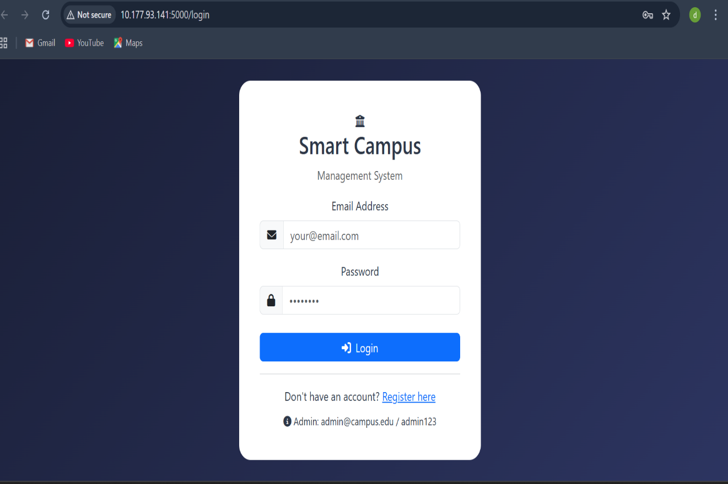
Figure 4.1.1 : Login Page

21

2. Student Dashboard
The student dashboard displays a summary of submitted complaints, their current statuses, and quick links to submit a new complaint or view the digital notice board. A greeting message shows the logged-in student's name.
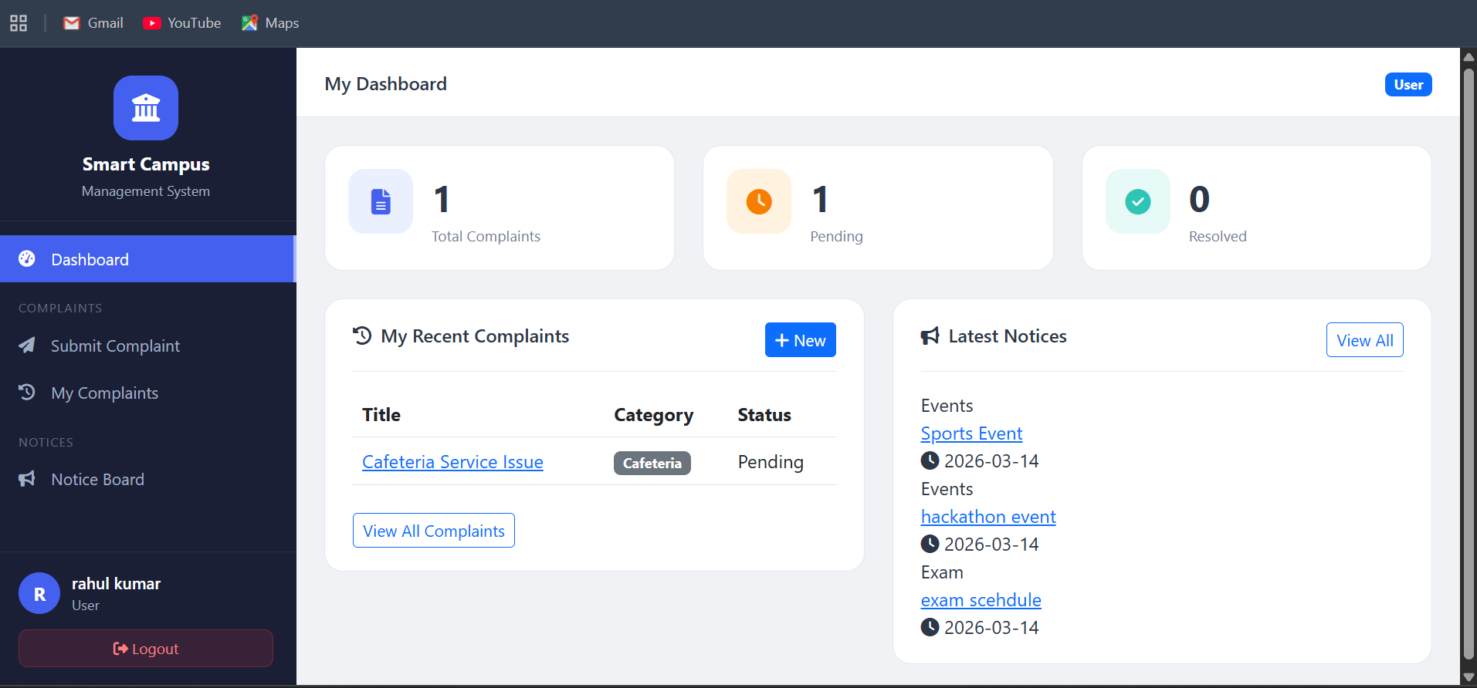
Figure 4.2.1 : Student Dashboard

22

3. AI Complaint Form Generator
This is the core feature screen where students enter a short instruction or set of keywords (e.g., 'Wi-Fi not working in hostel Block-C for 3 days'). Upon clicking 'Generate with AI', the system calls the AI backend which produces a formal, structured complaint with subject, category, and a detailed description. The student can review, edit, and then submit the generated form.
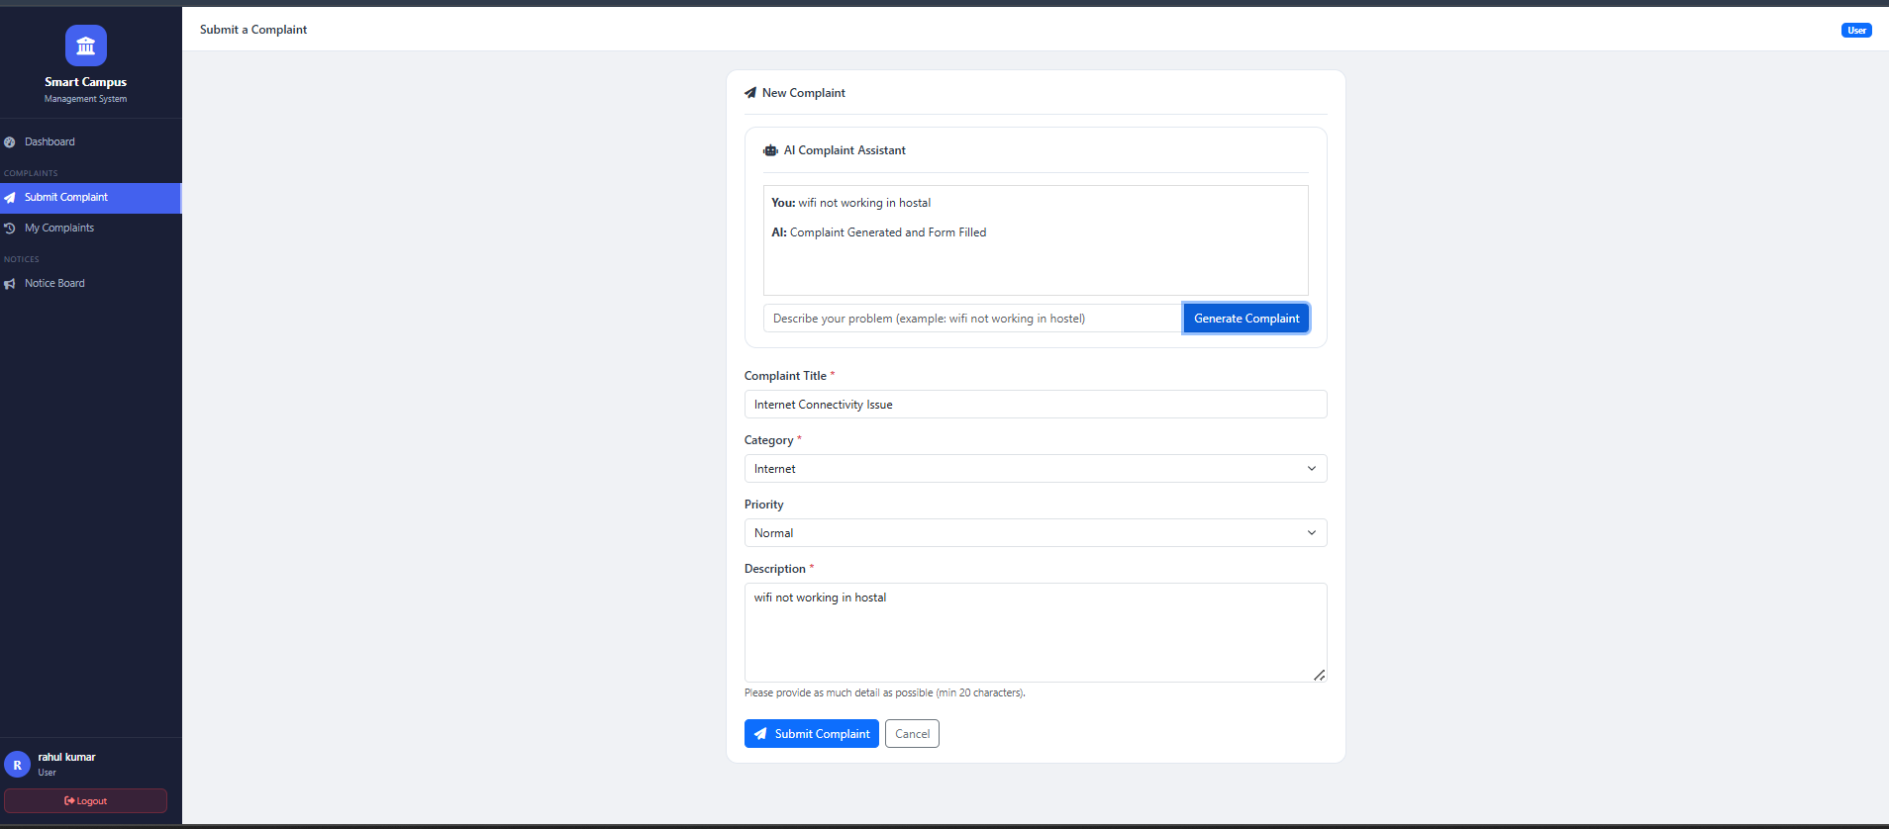
Figure 4.3.1 : Form Generator

23

4. Complaint Submission Form
The standard complaint submission form allows manual complaint entry as well. Fields include: Complaint Subject, Category (Academic/IT/Hostel/Infrastructure/Other), Description, and an optional file attachment. The AI Generate button appears at the top for quick AI-assisted filling.
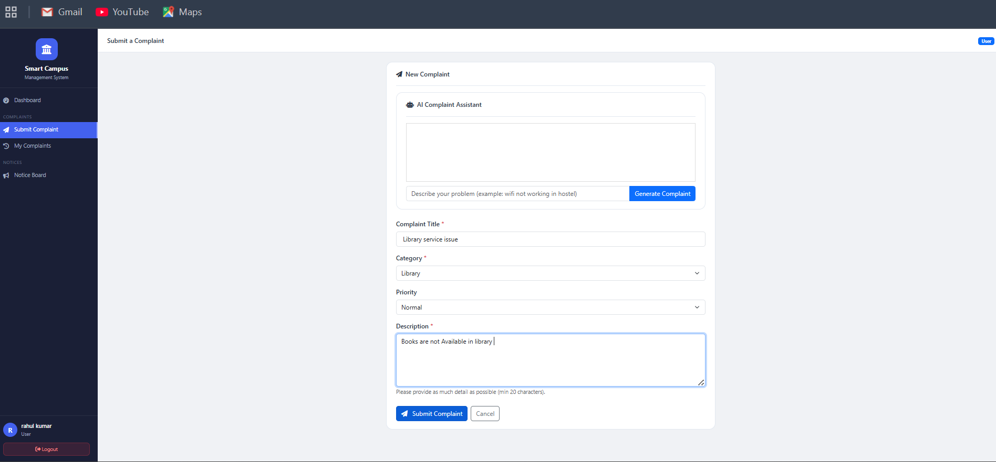
Figure 4.4.1 : Submission Form

24

5. My Complaints (Status Tracker)
Students can view a list of all complaints they have submitted. Each complaint card shows the Complaint ID, subject, category, submission date, and current status (Pending, In Progress, Resolved) with color-coded badges.
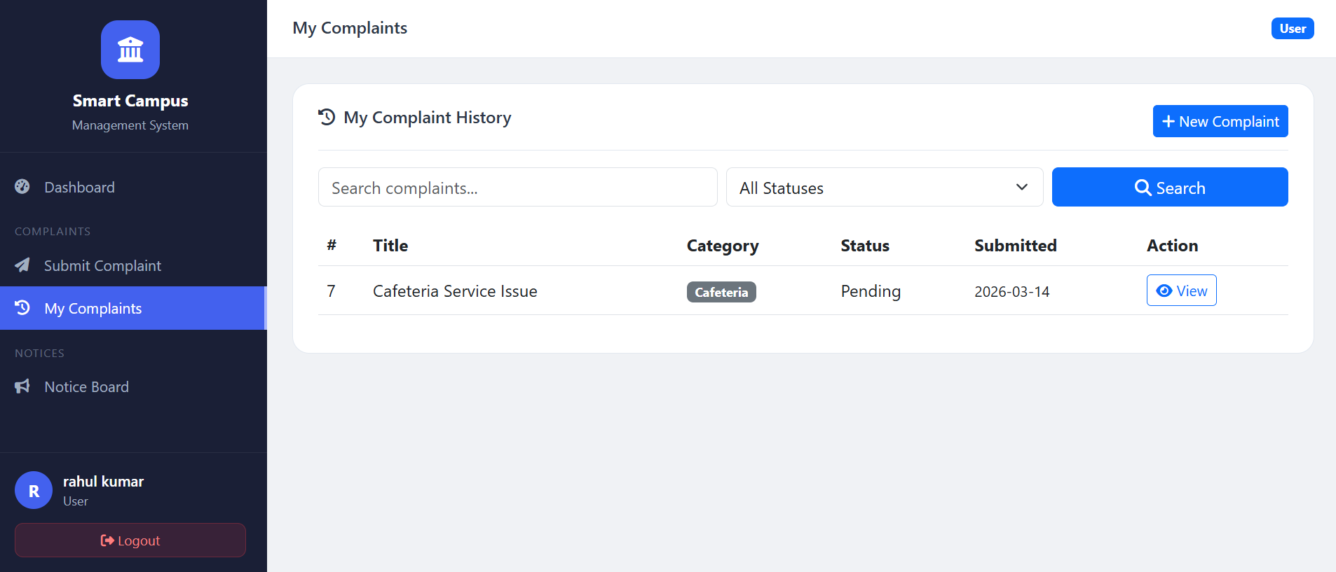
Figure 4.5.1 : Status Tracker

25

6. Digital Notice Board (Student View)
The digital notice board displays all active notices published by administrators. Notices are sorted by publication date and include title, category badge, content preview, and the expiry date. Students can search notices by keyword or filter by category.
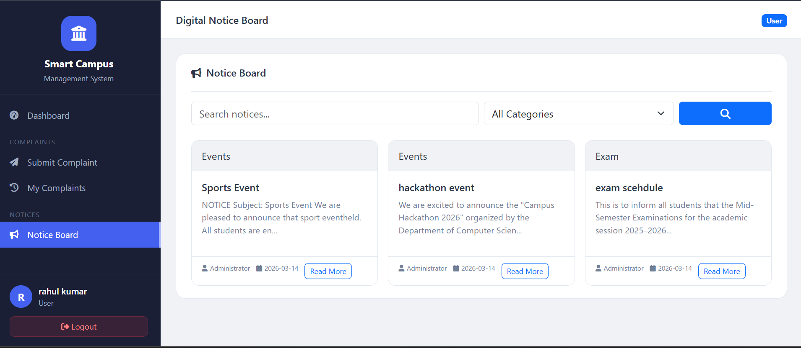
Figure 4.6.1 : Student View

26

7. Admin Dashboard
The admin dashboard provides a high-level overview of the campus system, including total complaints (by status), total active notices, total registered users, and recent activity logs.
Quick action buttons allow the admin to post a new notice or manage complaints directly.
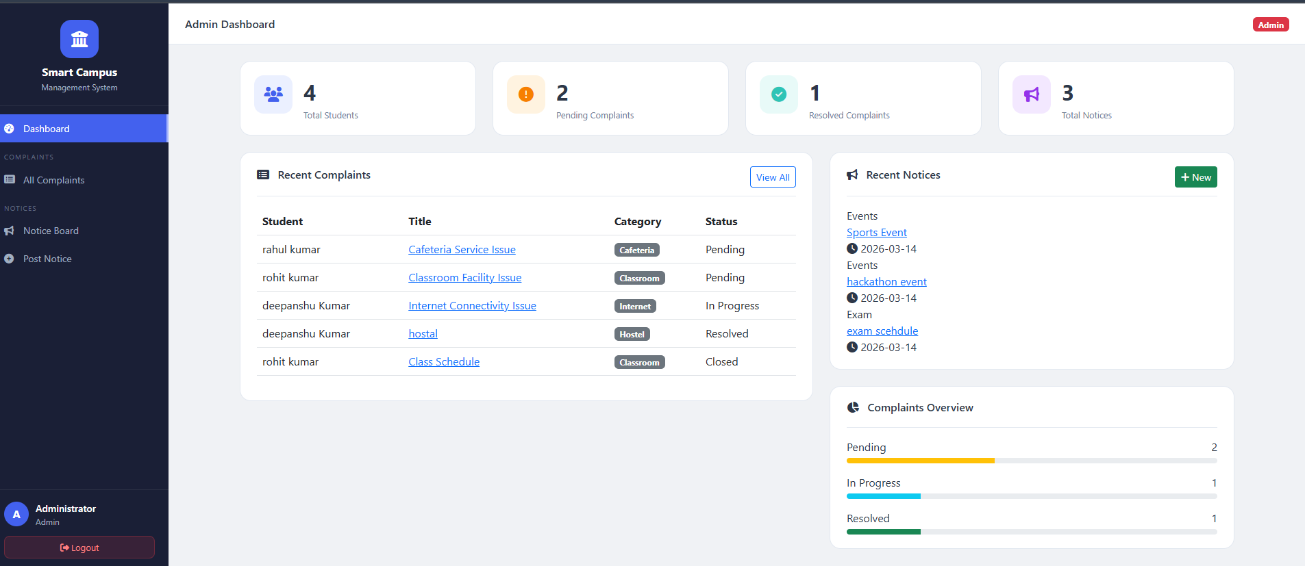
Figure 4.7.1 : Admin Dashboard

27

8. Admin – Manage Complaints
Administrators can view all submitted complaints in a filterable table. They can sort by status, date, category, or user. Each row includes an 'Update Status' button that opens a modal to change the complaint status and add resolution notes.

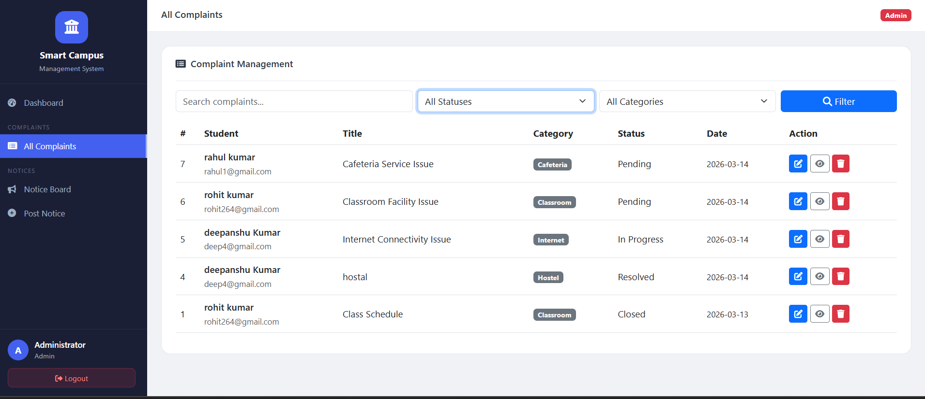
Figure 4.8.1 : Admin-Manage Compliants

28

9. Admin – Post New Notice
The notice creation form allows administrators to publish new digital notices. Fields include:
Title, Content (rich text editor), Category, Priority Level (Normal/Important/Urgent), and Expiry Date. Notices are instantly visible on the student-facing notice board upon posting.
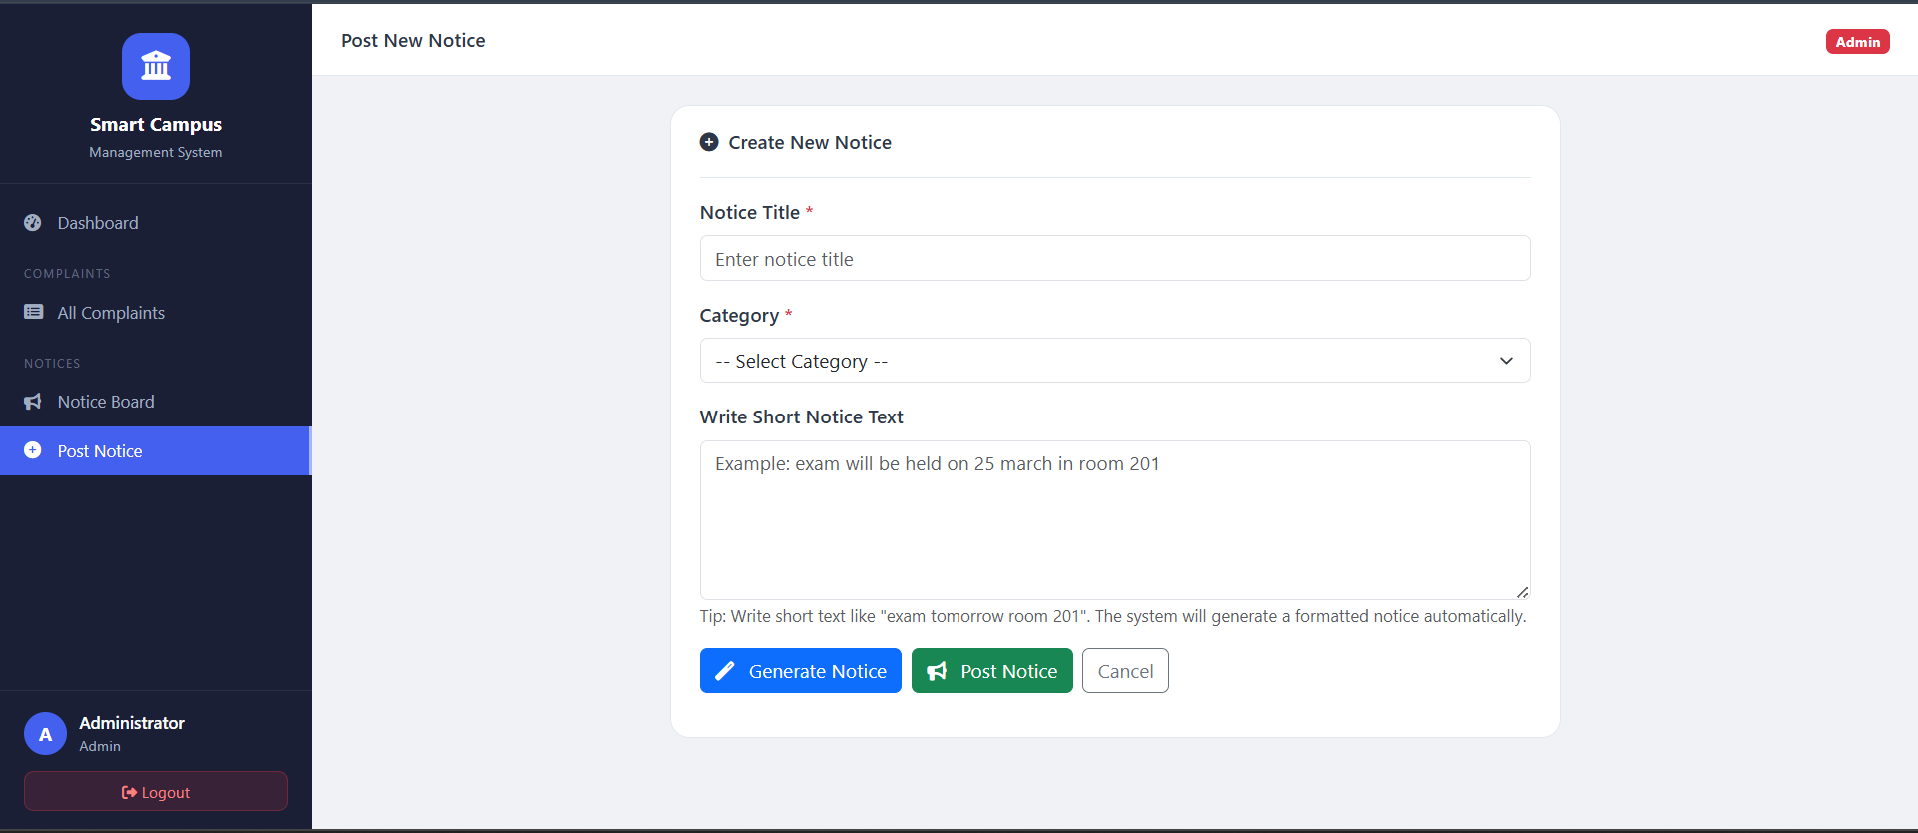
Figure 4.9.1 : Admin-Post New Notice

29

4.1 Future Scope
The AI Smart Campus Management System has been designed with scalability and extensibility in mind. The following enhancements and expansions are planned for future versions:
- Email/SMS Notification System: Automatically notify students via email or SMSwhen their complaint status is updated by the administrator.

- Complaint Priority Levels: Allow administrators to assign priority levels (Low,Medium, High, Critical) to complaints for faster resolution of urgent issues.

- Mobile Application: Develop a companion mobile app for Android and iOS using
React Native or Flutter to bring full complaint and notice functionality to smartphones.

- Notice Scheduling: Allow administrators to schedule notices to be automaticallypublished on a future date and time.

30
- Advanced AI Capabilities: Integrate advanced NLP models to analyze complaintpatterns and automatically categorize and prioritize incoming complaints without manual intervention.
- Sentiment Analysis: Use AI sentiment analysis on complaint descriptions to identifyemotionally charged or urgent complaints and escalate them automatically.
- Chatbot Integration: Add a campus chatbot powered by AI to answer common studentqueries, guide complaint submission, and provide notice summaries.
- Analytics Dashboard: Provide detailed analytics on complaint resolution times,common complaint categories, notice engagement rates, and user activity for data-driven administration.
- Multi-Campus Support: Scale the system to support multiple institutions or campusesunder a single platform with institution-specific data segregation.
- Blockchain for Complaint Integrity: Use blockchain technology to ensure complaintrecords cannot be tampered with, providing transparent and immutable resolution history.

31

CHAPTER-5

5.0 Conclusion
The AI Smart Campus Management System successfully demonstrates the practical application of Artificial Intelligence in solving real-world administrative challenges faced by educational institutions. By integrating an AI-powered complaint form generator with a digital notice board, the system offers a comprehensive solution that replaces slow, paper-based processes with fast, transparent, and intelligent digital workflows.
The Complaint Management module empowers students and staff to submit well-structured complaints with minimal effort, while giving administrators a centralized dashboard to track, assign, and resolve issues efficiently. The Digital Notice Board eliminates the limitations of physical bulletin boards by providing real-time, searchable, and categorized announcements accessible from anywhere.
The AI-assisted complaint form generation is a particularly innovative feature that demonstrates how natural language AI can simplify formal documentation tasks for non-technical users, reducing errors and saving time. Combined with role-based access control, responsive design, and an intuitive user interface, the system is both functional and user-friendly.
This project proves that AI integration in campus management is not only feasible but highly beneficial, and it lays a strong foundation for future enhancements such as mobile apps, sentiment analysis, and multi-campus deployment.

32

5.1 Advantages
The AI Smart Campus Management System offers the following key advantages:
- Time Efficiency: AI-assisted complaint form generation reduces the time students spend writing formal complaint descriptions from minutes to seconds.
- Transparency: Real-time complaint status tracking ensures students are always informed about the progress of their complaints without needing to follow up manually.
- Centralized Management: All complaints and notices are managed through a single platform, eliminating the need for multiple tools or offline registers.
- Paperless Operation: Digitizing complaints and notices removes the dependency on paper, reducing operational costs and environmental impact.
- Accessibility: The web-based, responsive design ensures the system is accessible from any device including smartphones, tablets, and desktops.
- Data-Driven Insights: The system stores historical data that can be analyzed to identify recurring issues, improve campus services, and optimize administrative workflows.
- Scalability: The modular architecture allows new features (notifications, analytics, mobile app) to be added without rebuilding the core system.
- Improved Communication: The digital notice board ensures timely and uniform communication of campus announcements to all students and staff simultaneously.

33

5.2 Limitations
Despite its advantages, the current version of the system has the following limitations:
- Internet Dependency: The system requires an active internet connection to function.
Offline access is not currently supported.
- AI API Dependency: The AI complaint form generation relies on third-party AI APIs (e.g., OpenAI). Any API downtime or cost increase can affect this feature.
- No Real-Time Notifications: The current version does not send push notifications or emails when complaint statuses are updated. Users must manually check the system.
- Limited AI Accuracy: The AI-generated complaint text may occasionally produce generic or slightly irrelevant descriptions that require manual editing by the user.
- No Mobile App: The system is currently a web application only. A dedicated mobile app is not yet available.
- Single Institution: The current build supports one institution. Multi-campus or multi-tenant support is not yet implemented.
- File Upload Size: Complaint file attachments are limited to small file sizes due to server storage constraints in the current deployment.

34

5.3 Enhancements
The following enhancements are proposed to improve the system in future iterations:
- Email & SMS Notifications: Integrate an email/SMS gateway (e.g., Twilio, SendGrid) to automatically notify users about complaint status changes and new important notices.
- AI Complaint Auto-Categorization: Train a custom classification model to automatically detect and assign the correct category (Academic, Hostel, IT, etc.) based on the complaint content.
- Two-Factor Authentication (2FA): Add an additional layer of security with OTP-based login for all user roles.
- Dark Mode: Implement a dark/light theme toggle to enhance usability for users working in low-light environments.
- Analytics Module: Build a visual analytics dashboard showing complaint resolution trends, average resolution times, most common complaint categories, and notice engagement statistics.
- Rich Text Notice Editor: Replace the plain text notice editor with a rich text editor supporting formatting, images, and hyperlinks for more professional-looking announcements.
- Complaint Escalation: Add an automatic escalation workflow where unresolved complaints older than a defined threshold are escalated to higher authorities.
- Multi-Language Support: Add Hindi and regional language support for complaint submission and notice reading to improve accessibility for non-English-speaking users.

35

BIBLIOGRAPHY

- Flask Documentation. (2024). Flask Web Framework (Python). Pallets Projects.
Retrieved from https://flask.palletsprojects.com/
- MySQL Documentation. (2024). MySQL 8.0 Reference Manual. Oracle Corporation.
Retrieved from https://dev.mysql.com/doc/
- OpenAI. (2024). OpenAI API Documentation – GPT Models. Retrieved fromhttps://platform.openai.com/docs/
- Mozilla Developer Network. (2024). HTML5, CSS3, and JavaScript Reference. MDN
Web Docs. Retrieved from https://developer.mozilla.org/
- Bootstrap Team. (2024). Bootstrap 5 Documentation. Bootstrap. Retrieved fromhttps://getbootstrap.com/docs/
- Sommerville, I. (2016). Software Engineering (10th ed.). Pearson Education.
- Pressman, R. S., & Maxim, B. R. (2020). Software Engineering: A Practitioner'sApproach (9th ed.). McGraw-Hill Education.
- Vaswani, A., Shazeer, N., Parmar, N., et al. (2017). Attention Is All You Need. NeuralInformation Processing Systems (NeurIPS).
- Hugging Face. (2024). Transformers Library Documentation. Retrieved fromhttps://huggingface.co/docs/transformers/
- Date, C. J. (2004). An Introduction to Database Systems (8th ed.). Addison-Wesley.
- W3Schools. (2024). SQL Tutorial. Retrieved from https://www.w3schools.com/sql/
- OWASP Foundation. (2024). OWASP Top Ten Web Application Security Risks.
Retrieved from https://owasp.org/www-project-top-ten/

36

